**Control Structure**

**Objectives:**

1. **To calculate sigma of n1 to n2**
2. **To calculate factorial of n**
3. **To calculate sigma of n1 to n2**

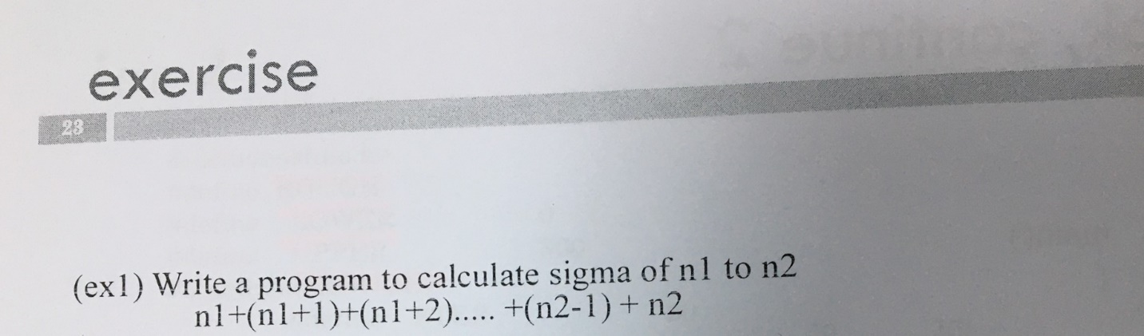

**Descriptions:**

* Declare variable n1 and n2.
* Variable type is integer.
* Use print statement to display n1 and n2 as inputs of type integer to assist users.
* Use scanf to get n1 and n2 from users.
* Total+ is (Total+1).
* Here I use “if” and “while” loops.
* These important to avoid repetitions.
* Relation statement is “if (n1 <= 0 || n2 <= 0) “means “if n1 or n2 less than zero (negative value) or equal zero, break /exit the program.
* Else: print sigma n1 and n2.
* If n1 or n2 more than zero print sigma n1 and n2.
* Initialize total (total=0). Loop “for” use to “initialize, condition and increment for variable “I”) as “for (i = n1; i <= n2; i++)”.
* When total += i; can return the value.
* If n1=2, n2=5 ; total 14; if n1=1 , n2=2 ; total is *3 (****Figure 1****).*
* Consider n2>n1.

**Code:**

#include<stdio.h>

int sigma(int n1, int n2);

main()

{

int n1, n2;

while (1){

scanf("%d", &n1);

scanf("%d", &n2);

if (n1 <= 0 || n2 <= 0)

break;

printf("sigma=%d", sigma(n1, n2) );

}

}

int sigma(int n1, int n2){

int i, total;

total = 0;

for (i = n1; i <= n2; i++)

total += i;

return total;

}

**Answer**

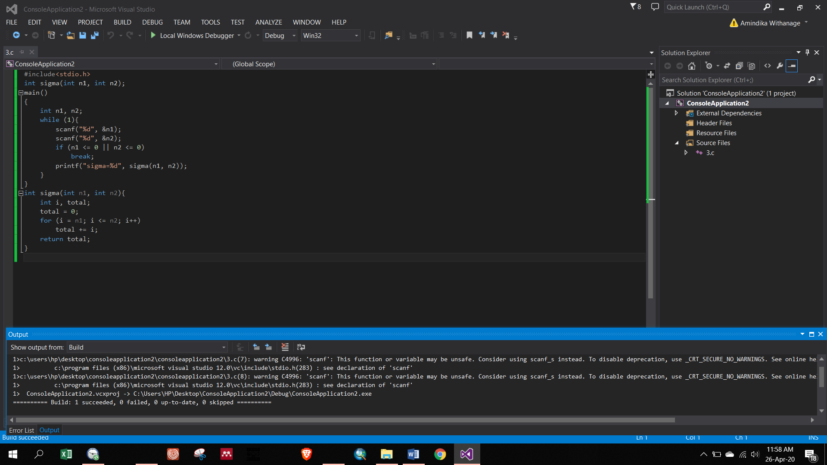

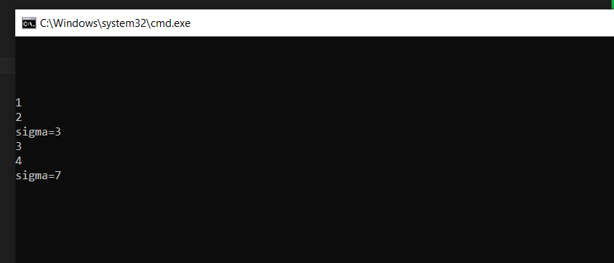

**Figure 1: answer for ex 1**

1. **To calculate factorial of n**

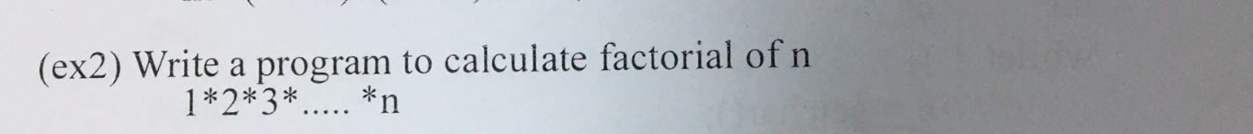

**Descriptions:**

* + Initialize directive
  + Factorial represent 1*2*3*…*n.
  + Long factorial is used in the code.
  + In main()
  + N is variable and its data type is int
  + Print “enter a number”
  + Scan it is address as “&n” data type of address is “d”
  + Print factorial
  + If n>=o return value of factorial n, if not break.
  + For loop’s initialize, condition and increment is “ for (i = 1; i<= n; i++)”
  + Initialize fact=1 and i=1
  + As i reaches n, terminate loop and return fact
  + N=6; n! is equal 720 ; n=4; n!=24 ***(Figure 2).***

**Code:**

#include<stdio.h>

long factorial(int);

main ()

{

int n;

printf("Enter a number\n");

scanf("%d", &n);

printf("%d! = %ld\n", n, factorial (n));

return 0;

}

long factorial(int n)

{

int i;

long fact = 1;

for (i = 1; i<= n; i++)

fact = fact*i;

return (fact);

}

**Answer**

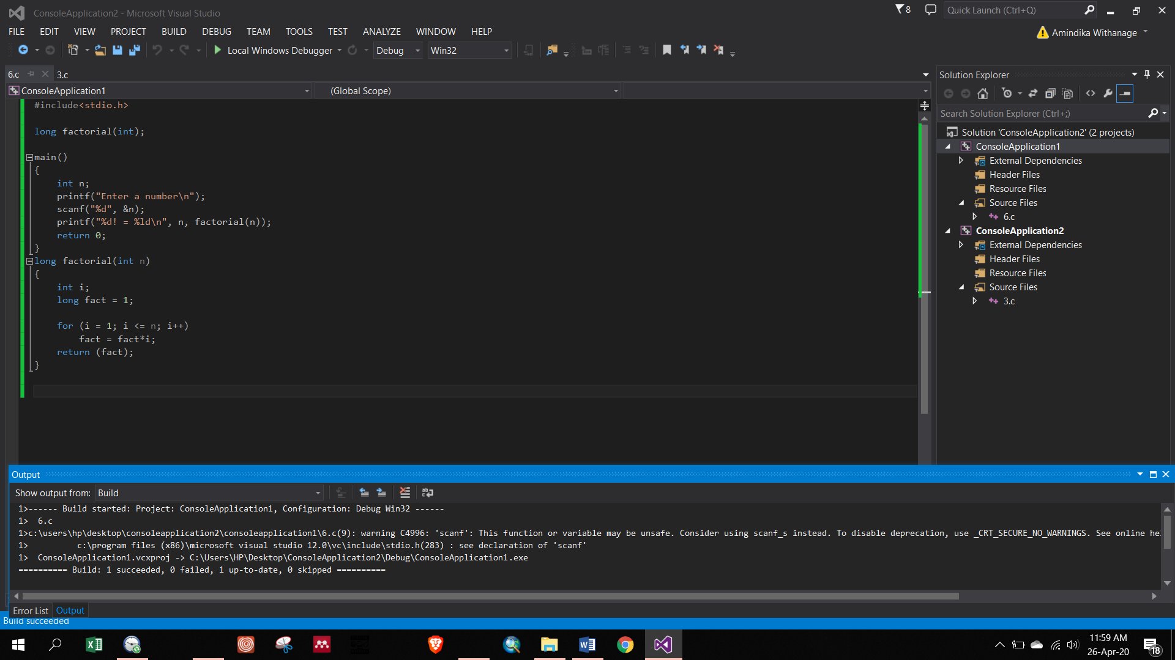

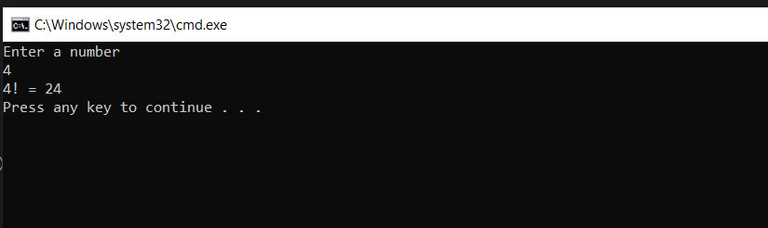

**Figure 2: answer for ex 2**